Corey Gaspar
3/28/2026
4-4 Assignment: UI Design
For this assignment, I decided to redesign the library page in Spotify. I feel that the library screen can sometimes feel cluttered and somewhat difficult to navigate, especially when you have many different playlists, albums, or artists saved.

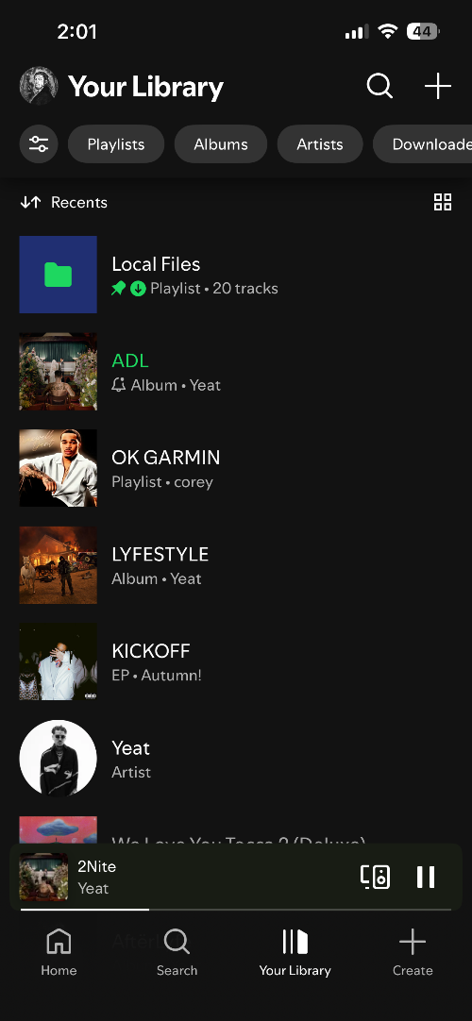 | 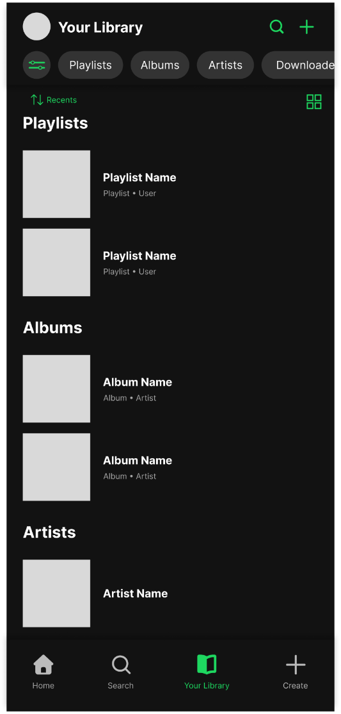
Figure 1: Current Library Figure 2: Updated Library
To improve the current design of the library, I decided to separate content into clearly labeled sections for playlists, albums, and artists. This allows users to find the content they want without needing to scroll through a large, mixed list. This change improves organization and reduces confusion when finding content in the library.
I also made important interactive buttons such as the search button, green so they stand out more and are easier to identify. This makes it easier for users to recognize what they can tap on. In addition, I made the active page in the navigation green. In this example, since the Library page is active, the tab is green. This just makes the page that the user is on more apparent.

